# Arch Review Documentation - Form 22-10215.

Product description:

* Statement of Assurance of Compliance with 85% Enrollment Ratios (VA Form 22-10215)

UX design description:

* [VEBT Form 22-10215: Statement of Assurance – Figma](https://www.figma.com/design/f9TussyZYnC5UVSnqBPJqC/VEBT-Form-22-10215%3A-Statement-of-Assurance?node-id=907-20127&t=rVCexO0yX0egANox-0)
* Changes made based on Midpoint Review, awaiting final feedback from Staging Review.

Architecture Diagram: -

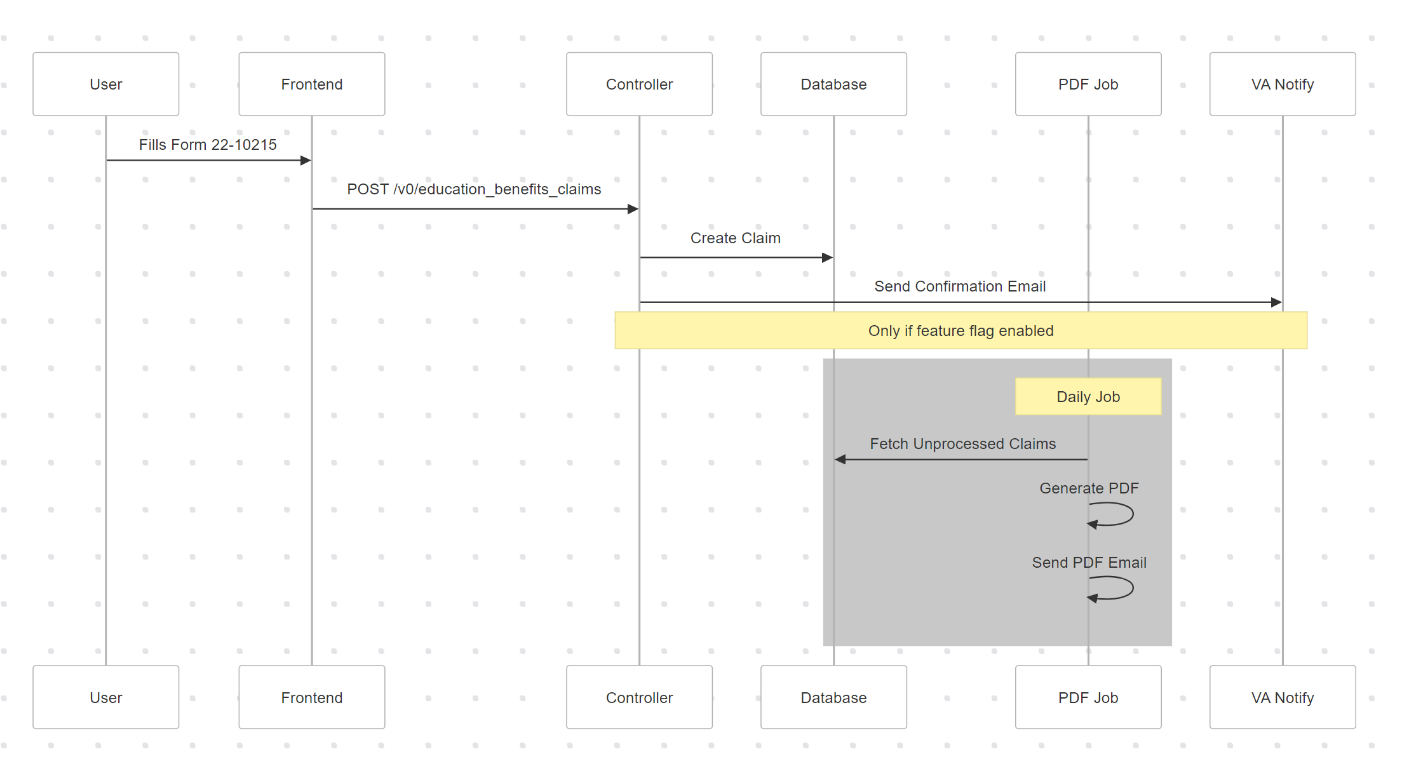

* User submission flow
* Controller interactions
* PDF file generation
* Email notifications.

Security Approach:

• Uses existing education benefits security model

• Standard VA.gov security controls

• Unauthenticated form submission

Dependencies:

• VANotify service for confirmation emails

• Existing education benefits infrastructure

• Standard VA.gov components

**Incident Response Plan:**

Points of Contact:

• Primary: VEBT team

• Slack Channels:

• #vfep-developer-support (main alerts)

• #vsa-education-logs (additional logging)

Security Fix Timeline:

• Follow standard VA.gov security patch process

• Immediate response to critical vulnerabilities

• Coordination with platform team as needed

Sequence Diagram:

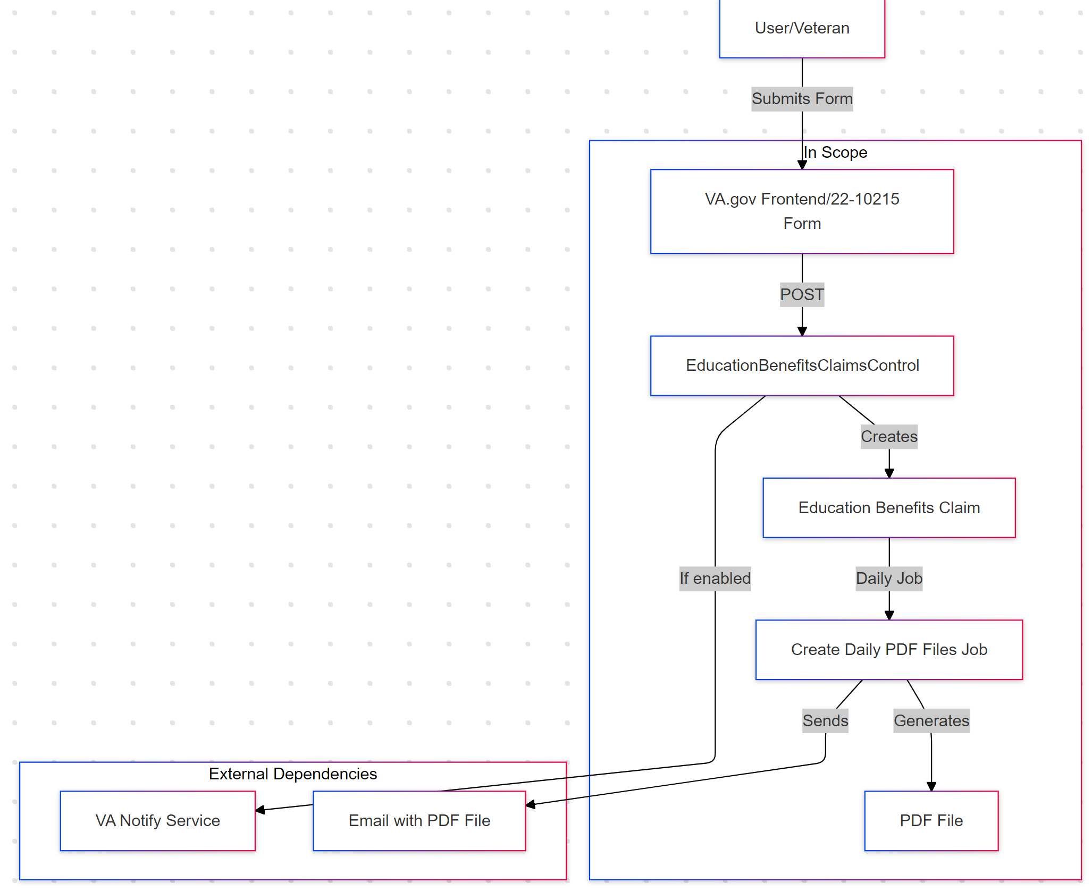

* User submission flow
* Controller interactions
* PDF file generation
* Email notifications.

Data Flow Diagram:

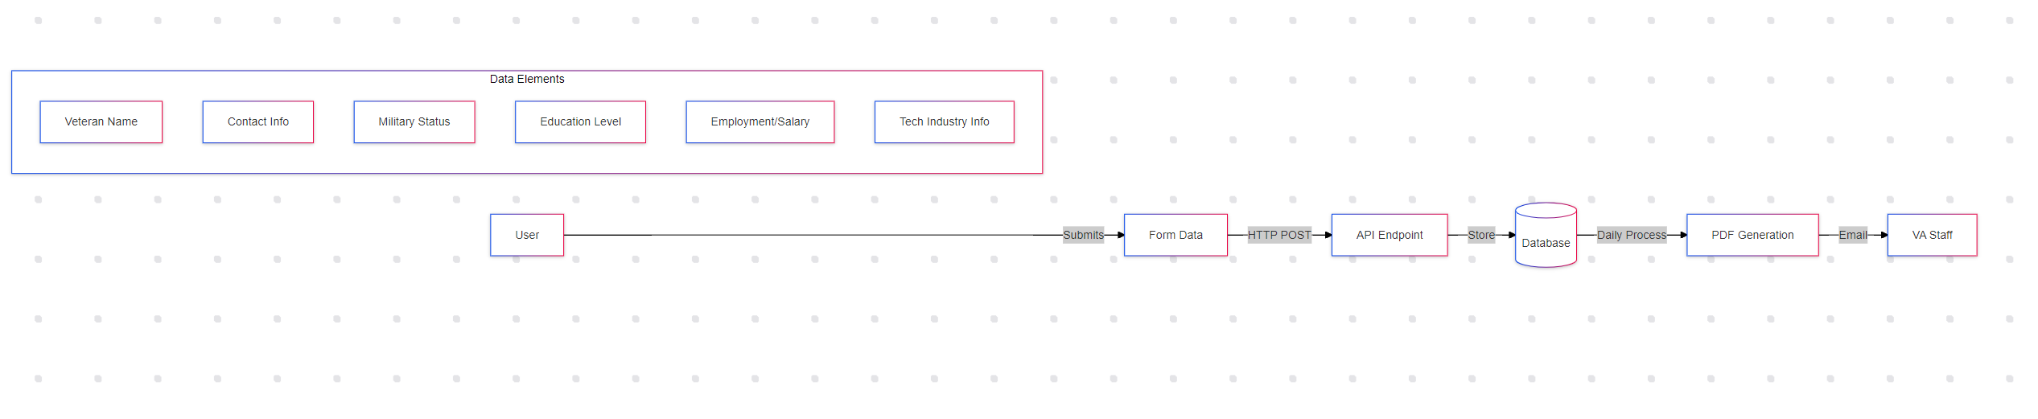

* Data collection points
* Storage locations
* Access patterns
* Processing flow

Data Collection:

* Veteran name
* Contact information (email, phone)
* Military status
* Education level
* Employment/salary information
* Technology industry information

Data Storage:

* Standard database encryption
* Temporary file storage for Excel files
* Secure email transmission

Access Control:

* Public form submission
* Restricted Excel file access
* Limited email distribution

## API Endpoint Documentation:

Endpoint: POST /v0/education_benefits_claims/10215

* Part of existing education benefits claims controller
* Uses same pattern as other education forms (i.e. 22-10203)
* Standard input validation

## Monitoring Plan

Datadog Monitoring:

* Education Benefits Claims dashboard
* P3 monitor for non-4XX errors
* P4 monitor for anomalous traffic
* Excel file generation metrics: worker.education_benefits_claim

## Security Monitoring Plan

Code Base Security:

1. Compromise Detection
   * Monitored via existing Datadog alerts
   * Abnormal traffic patterns detected by P4 monitor
   * Server errors caught by P3 monitor
2. Process Execution
   * Runs within existing education benefits claims infrastructure
   * Uses same security model as other education forms
   * Authentication not required (public-facing form)
3. Disabling Process
   * Feature flag control for email notifications
   * Can be disabled via existing education benefits controls

## New Logging:

1. Standard Controller Logging:
   * Request/response logging via existing controller
   * Error logging to standard Rails logs
2. Excel File Generation Logging:
   * Job execution status
   * Number of records processed
   * Email delivery status

## Cookies:

* No new cookies introduced
* Uses standard VA.gov session management
* No modifications to existing cookies

## Authentication Status:

* Unauthenticated form (public-facing)
* Same security model as form 22-10203
* No login required for submission

## Release Plan

Phase I - UAT:

1. Planning
   * Test on staging environment
   * Verify Datadog monitoring
   * Confirm alert routing
   * Test Excel file generation

Phase II - Limited Release (available if desired):

1. Planning
   * Monitor form submissions in production
   * Track Excel file generation success rate
   * Verify email notifications (when feature flag enabled)
   * Review Datadog metrics for errors/issues

Go Live:

1. Planning
   * Full production deployment
   * Active monitoring via Datadog dashboard
   * Excel file generation monitoring
   * Alert response via established playbook

## Potential Abuse Scenarios & Mitigation:

1. Form Submission Abuse
   * Rate limiting via existing VA.gov controls
   * Input validation on all fields
   * Same protections as other education forms
2. Excel File Access
   * Limited to authorized email recipients
   * Secure file generation process
   * Audit trail of file creation and sending

## Data Storage and Security:

1. Database Storage
   * Uses existing education benefits claims tables
   * Excel File Events table for tracking:
     + File generation attempts
     + Number of submissions
     + Success/failure status
     + Retry attempts
   * Standard VA.gov database security
   * Regular data cleanup processes
2. File Storage:
   * Temporary Excel file storage
   * Files deleted after email sending
   * Access limited to job process

[Note: Product Outline link and business details to be provided by Business Analyst/Frontend team]